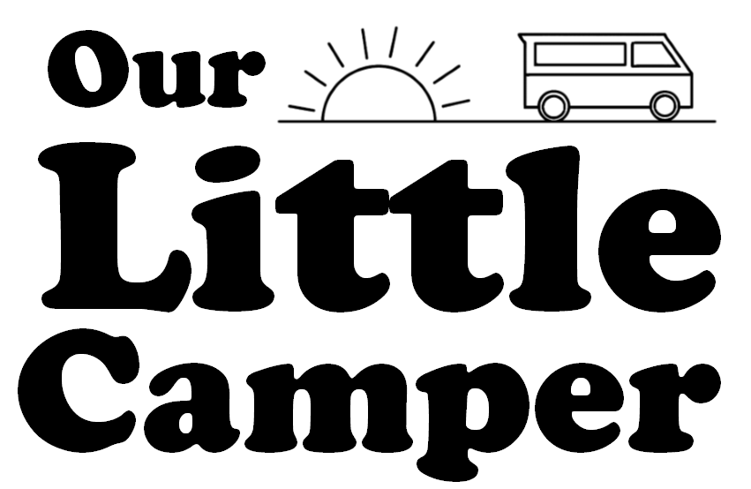
-----RENTAL AGREEMENT -----
Each driver will need to complete and sign a separate rental agreement in order to be fully insured to drive OurLittleCamper.

Full Name _________________________
Title Mr/Mrs/Miss
Date of Birth ___/___/___
Home Address _____________________________________________________________
__________________________________________________________________________
Driver’s Licence Number _______________________
National Insurance Number ___________________
Please tick the boxes to confirm the following are true:
- I have read and agree with the Terms and Conditions set out in this contract
- I have held a full UK licence for a minimum of 24 months
- I am aged between 21-79
- I have no more than 6 points on their licence (providing they are two minor offences)
- I have no more than one fault or non-fault claim within a 5 year period
- I give permission for OurLittleCamper Limited to carry out a check with the DVLA to confirm my driver’s licence details
- I have provided a copy of my current driver’s licence and two forms of ID with proof of address
- I have checked and signed the itinerary list and vehicle damage sheet and am happy with the condition of the vehicle
I confirm that all of the above information is correct and that I agree to be bound by OurLittleCamper terms and conditions which I have had the opportunity to see and read.
Full Name______________________________
Signed _________________________________ Date ___________

------ OFFICE USE ONLY------

On behalf of OurLittleCamper I confirm that I have seen and made copies of all the above documentation and that I have made the necessary checks with DVLA to confirm that the above statements are true. ( https://www.viewdrivingrecord.service.gov.uk/driving-record/licence-number )

Full Name______________________________

Signed _________________________________ Date _____________

On behalf of OurLittleCamper I can confirm that I have received the security deposit stated below and I will return this to the hirer, less a reasonable sum for any damage or missing items, on return of the vehicle once the vehicle has been checked for damage.

Full Name______________________________ Deposit Amount_______________

Signed _________________________________ Date _____________

DATES AND TIMES

Pick up date ______________________________Pick up time _______________________
Pick up location _____________________________________________________________

Drop off date _____________________________Drop off time_______________________
Drop off location ___________________________________________________________

Pick up mileage_______________________ Drop off mileage _______________________

I confirm that the above dates have been agreed by both myself and OurLittleCamper.

Full Name______________________________

Signed _________________________________ Date _____________

On behalf of OurLittleCamper I can confirm that that the above details have been agreed with the hirer.

Full Name______________________________

Signed _________________________________ Date _____________

